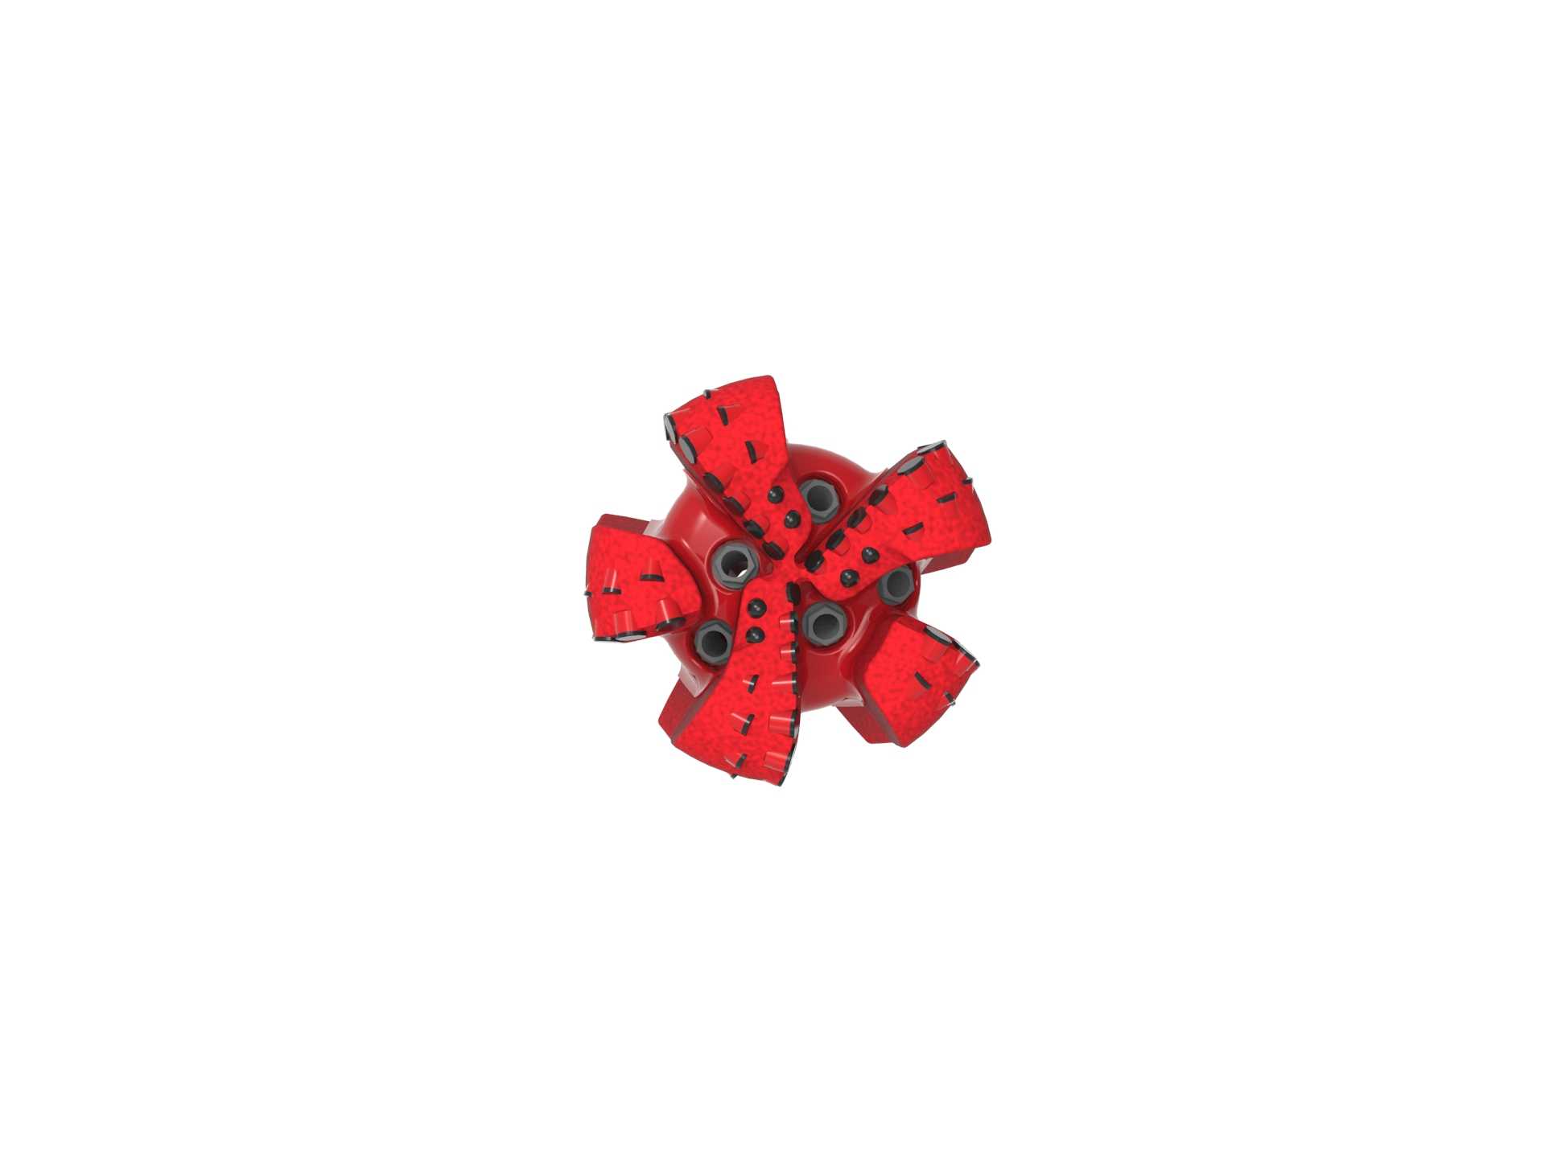
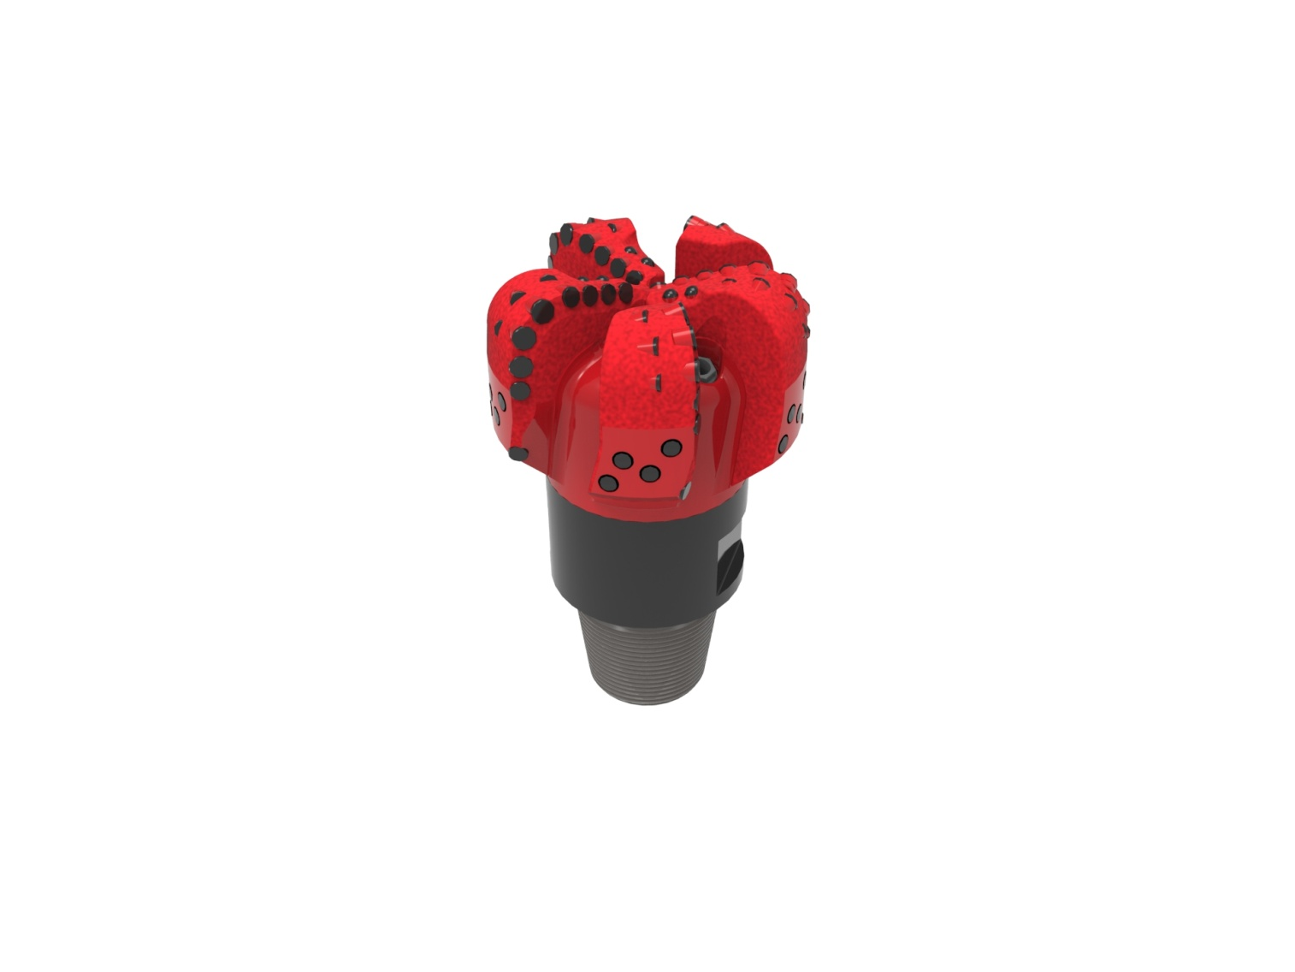

Drill Bit Specifications:
Cutter Size (Primary, Sec) | 5/8”,1/2”
Cutter Count (Total, Gage) | 55, 5, 5
Blade Count | 5
Gage Length (Inches) | 2.00
Nozzle Count (Primary, Sec.) | 5
Nozzle Series (Primary, Sec.) | 60
JSA (Sq. Inches) | 14.08
Max. TFA (Sq. Inches) | 1.85
Operating Parameters:
Max. Hydraulic Flow Rate (GPM) | 255-670
Max. Weight on Bit (1,000 Lbs.) | 50
Make-up Torque (ft/lbs) | 16,488
Nominal Dimensions:
Overall Length (Inches) | 14.10
Make Up Length (Inches) | 10.04
Bit Breaker | SKB-21010
Connection | Ø4-1/2" API Reg.
Approx. Weight (Lbs.) | 95

Standard Features:

- Short bit length improves steerability
- Large open face volume assists cuttings removal
- Five nozzles optimize blade cleaning and cuttings removal
- Premium grade cutters maximize ROP and Life
- PDC inserts for increased gage protection

516-YR(K)(BR) Nomenclature Explained:

• | 5 | = | Number of blades
• | 16 | = | Primary Cutter Size (16mm)
• | YR | = | Double Row of Cutters
• | K | = | Bullets
• | BR | = | Back Reaming Cutters


